# Java Web Development Basics

# Java EE Workshop – Servlets & JSP

# West Compass Car Dealer Shop

West Compass Dealer Shop is an web application where you can add your car offers. There are two main entities, Users and Cars .

## Database Requirements

The **Database** of the application needs to support **2 entities**:

### User

* Has a Username
* Has a Password
* Has an Email
* Has Cars (a collection of cars)

### Car

* Has a Brand
* Has a Model
* Has a Year
* Has an Engine
* Has User

Implement the entities with the **correct datatypes**, and implement **repositories** for them.

## Templates

### Index Template (route = “/index”) (logged out user)

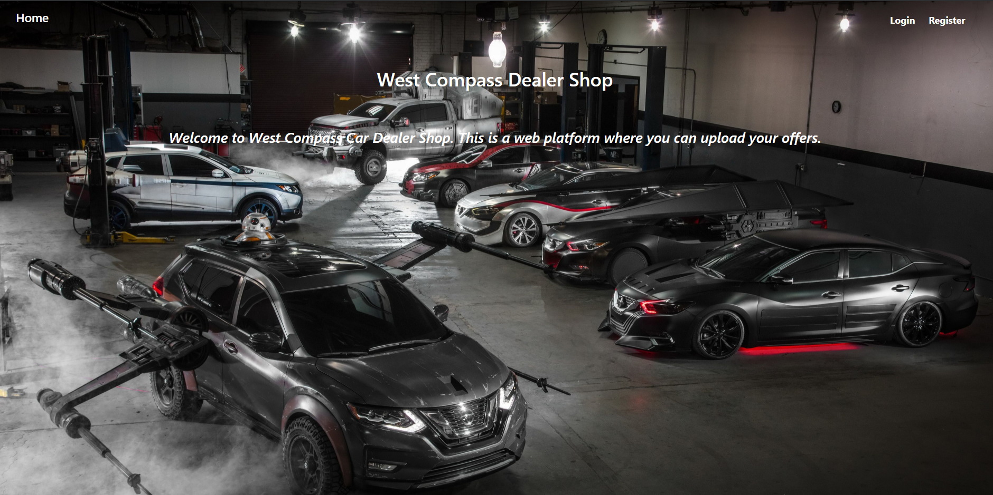

### Login Template (route = “/users/login”) (logged out user)

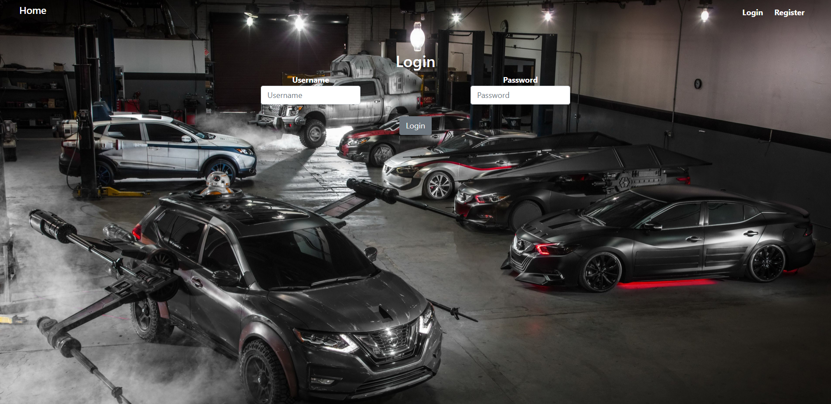

### Register Template (route = “/users/register”) (logged out user)

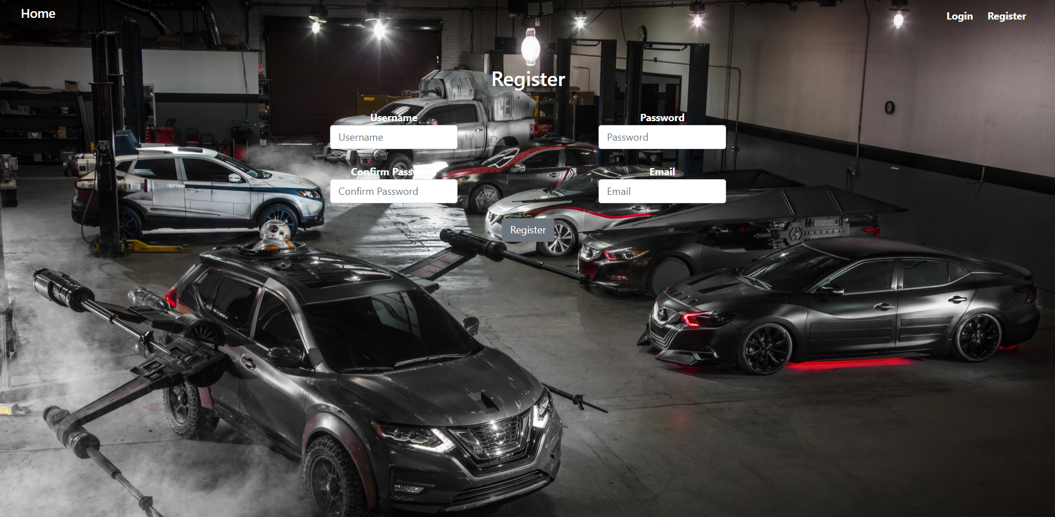

### Home Template (route=”/home”) (logged in user)



### Cars Create Template (route=”/cars/create”) (logged in user)

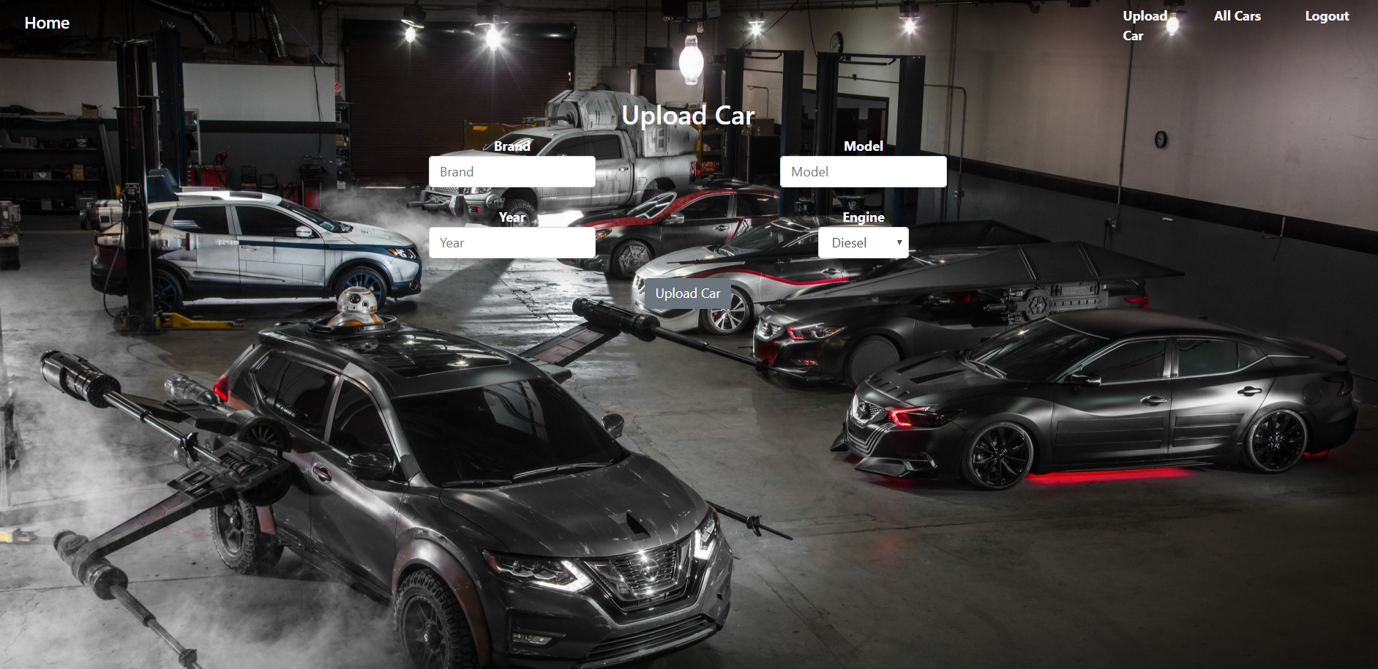

### Cars All Template (route=”/cars/all”) (logged in user)

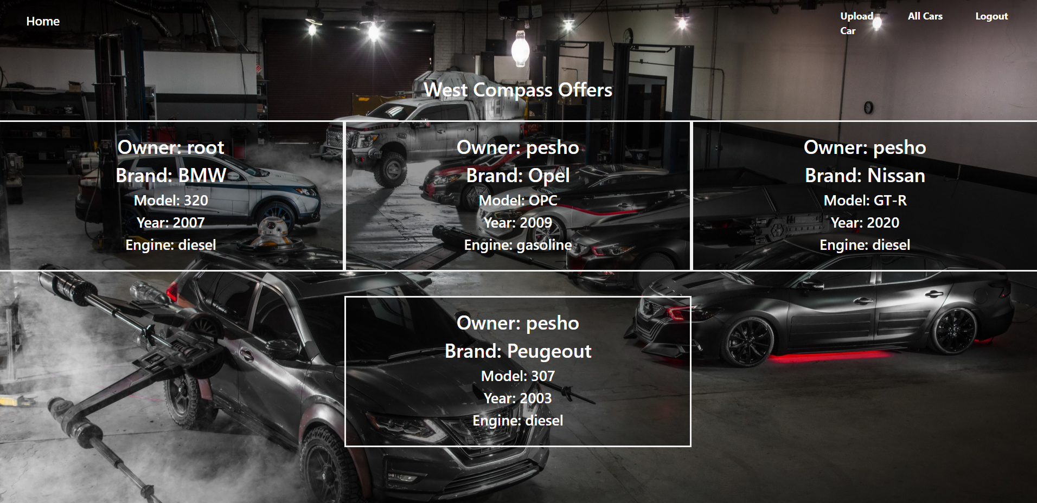

**NOTE**: All the templates have been given to you as .html files. You need to make .jsp files from them.

**NOTE**: The templates do **NOT** **require** **additional** **CSS** for you to write. Only **bootstrap** and the **given css** are enough.

**NOTE:** To **include** the proper **CSS** use "$**{pageContext.request.contextPath}/css/style.css**".

## Functional Requirements

The Functionality Requirements describe the functionality that the **Application** must support.

For **Index** you should use exactly "**/index"** as URL, not "**/**".

The **application** should provide Guest (not logged in) users with the functionality to:

* Login
* Register
* **View** the Index page.

The **application** should provide Users (logged in) with the functionality to:

* Logout
* Home
* **View** all Cars (All Cars page)
* **Create** a Car.

The **application** should **store** its **data** into a MySQL database, using Hibernate native.

## Security Requirements

The Security Requirements are mainly access requirements. Configurations about which users can access specific functionalities and pages.

* Guest (not logged in) users can access Index page.
* Guest (not logged in) users can access Login page.
* Guest (not logged in) users can access Register page.
* Users (logged in) can access Home page.
* Users (logged in) can access Cars Create page.
* Users (logged in) can access Cars All page.
* Users (logged in) can access Logout functionality.